1. We are going to implement our 1st Kafka Consumer.A screenshot of a computer

   Description automatically generated
2. A screenshot of a computer

   Description automatically generated
3. **Code**:
4. 
5. 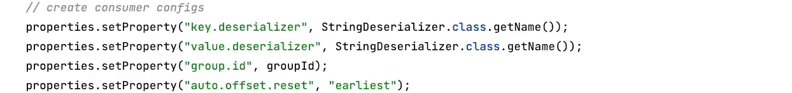
6. 
7. 
8. A screenshot of a computer

   Description automatically generated
9. A white background with black text

   Description automatically generated
10. 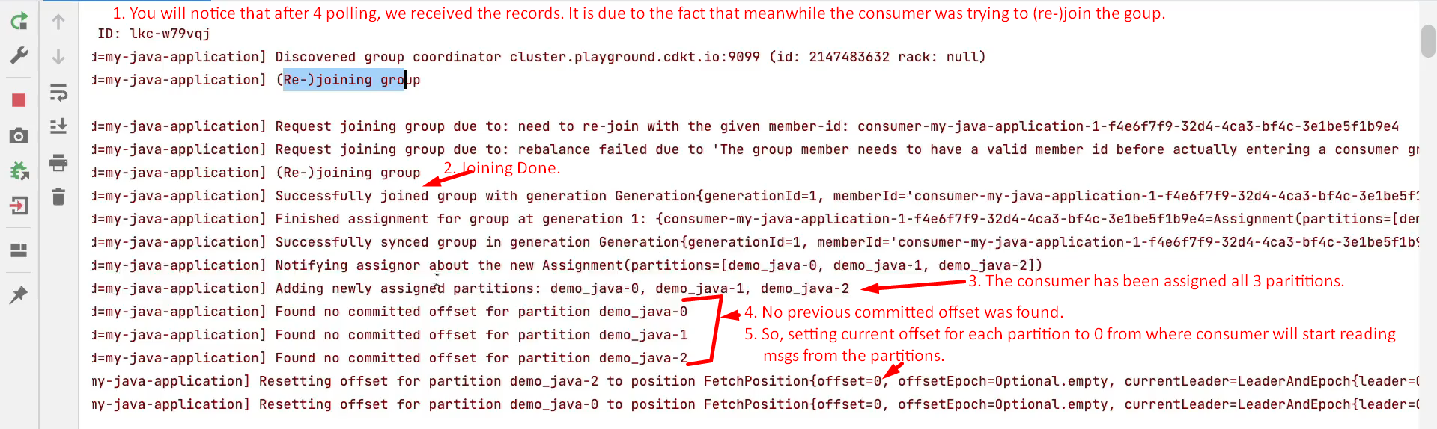
11. When restarting the consumer with existing groupid.  
    A screenshot of a computer

    Description automatically generated